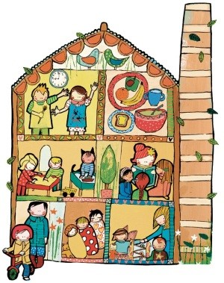
Crossley Mill Nursery Closure dates 2022

Monday 3 January – New Year’s Day
Friday 15 April – Good Friday
Monday 18 April – Easter Monday
Monday 2 May – Early May Bank Holiday
Thursday 2 June – Spring bank holiday
Friday 3 June – Platinum Jubilee bank holiday
Monday 29 August – Summer bank holiday

Christmas Closure- Friday 23rd December @ 3.30pm till Tuesday 3rd January 2023

The nursery will also be closed for 2 training days throughout 2022, these dates are yet to be confirmed but we will always give you 4 weeks written notice prior to any closure.

